Travel Itinerary Planner

In this project we have designed all modules given by you and this modules are divided between 3 users

1. Admin can login to system using username and password as ‘admin and ‘admin’. After login admin will add employee details and can view available employee details. Admin can view all authenticated employees login details by selecting FROM and TO date.
2. Employee: employee can login to system by using login details provided by admin. After login employee will create, modify Itinerary details, create, and modify transport and hotel details. Employee can view all bookings and feedback given by user
3. Register: new user can sign up with the application and then view and book Itinerary, transport and hotel. User can cancel or give feedback and ratings to provided services
4. FAQ: can view answers from frequently asked questions

To run project install MYSQL and then copy content from ‘db.txt’ file and paste in MYSQL console to create database.

To run project double click on run.bat file to start python server and get below page

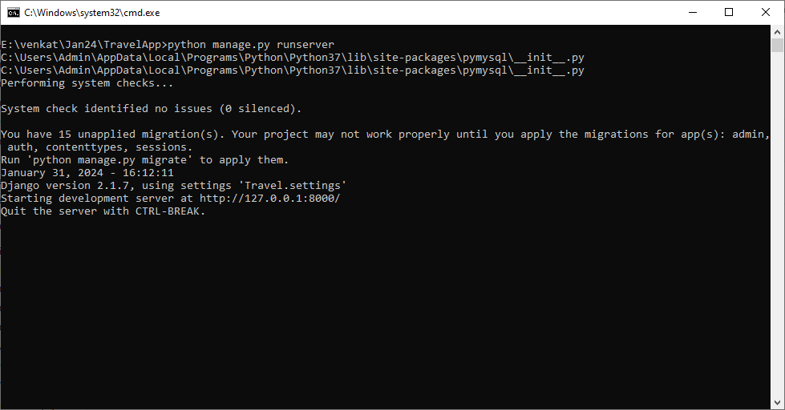

In above screen python server started and now open bowser and enter URL as <http://127.0.0.1:8000/index.html> and press enter key to get below page

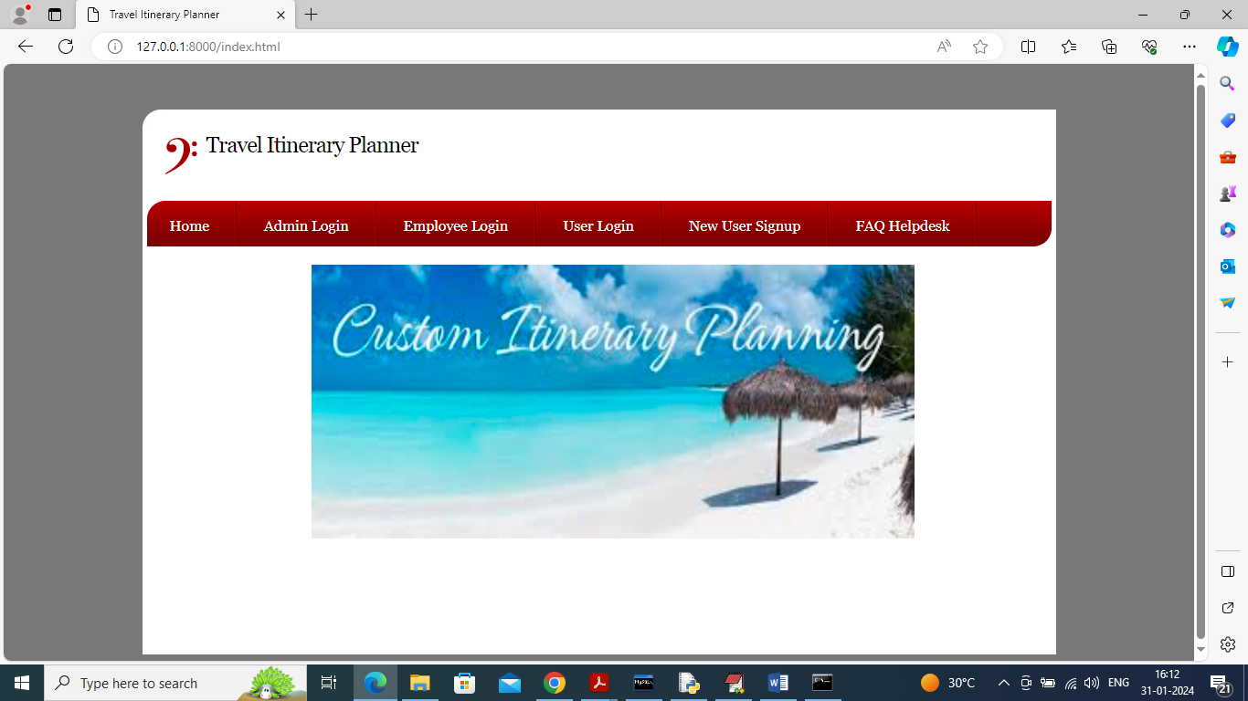

In above screen click on ‘FAD’ link to view FAQ answers

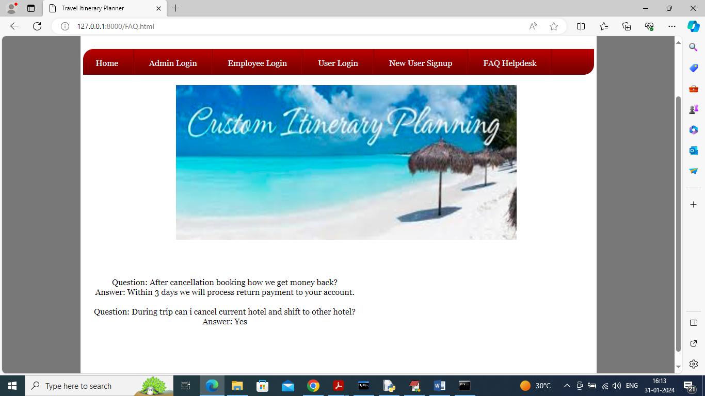

In above screen we have added few questions and you can add few more by opening FAQ.html file and now click on ‘Admin Login’ link to get below page

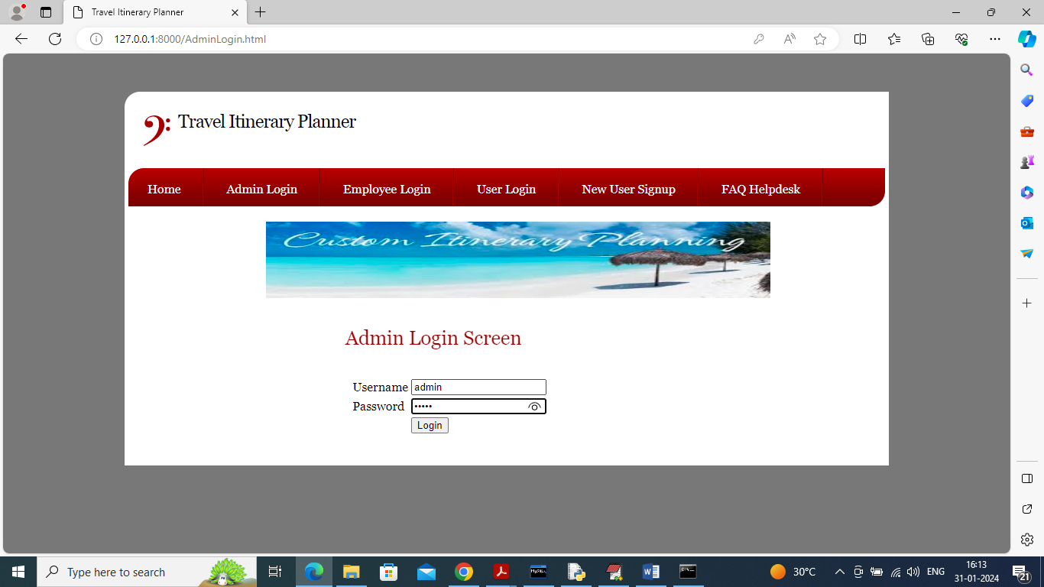

In above screen admin is login and after login will get below page

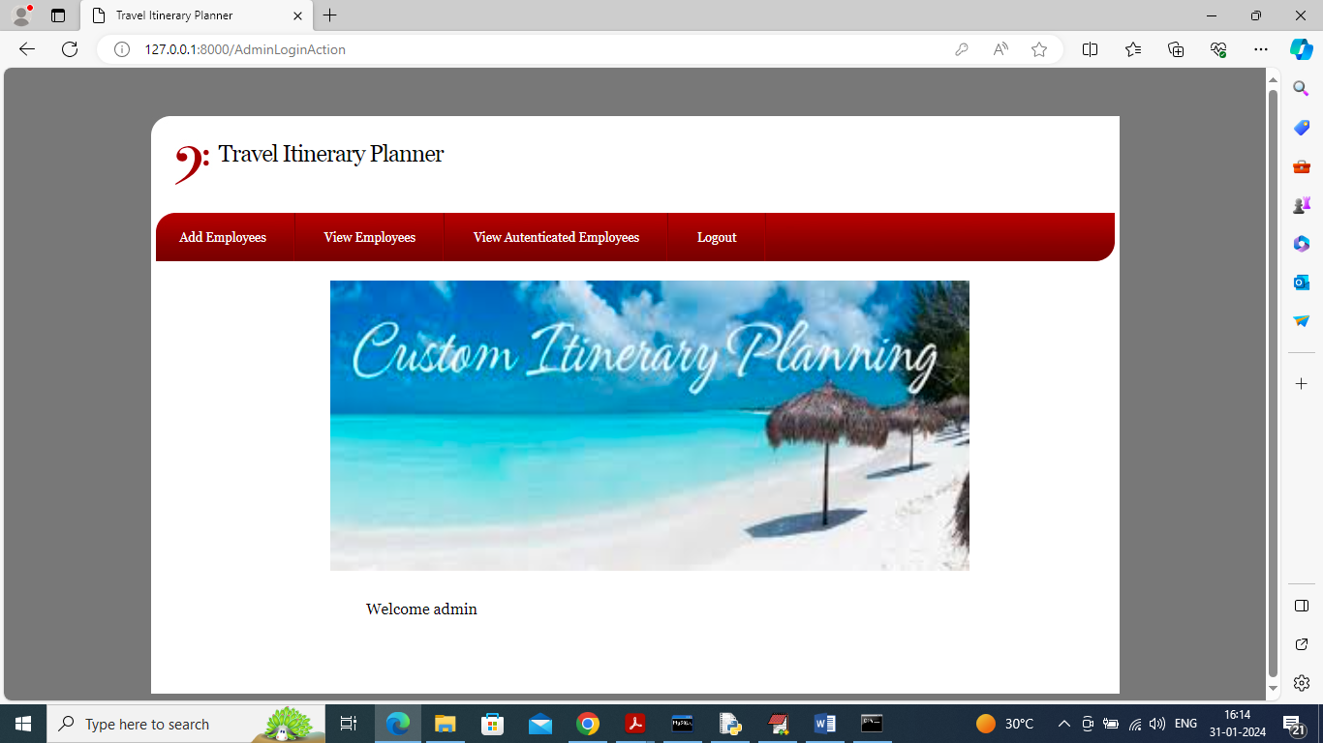

In above screen admin can click on ‘Add Employee’ link to add employee details

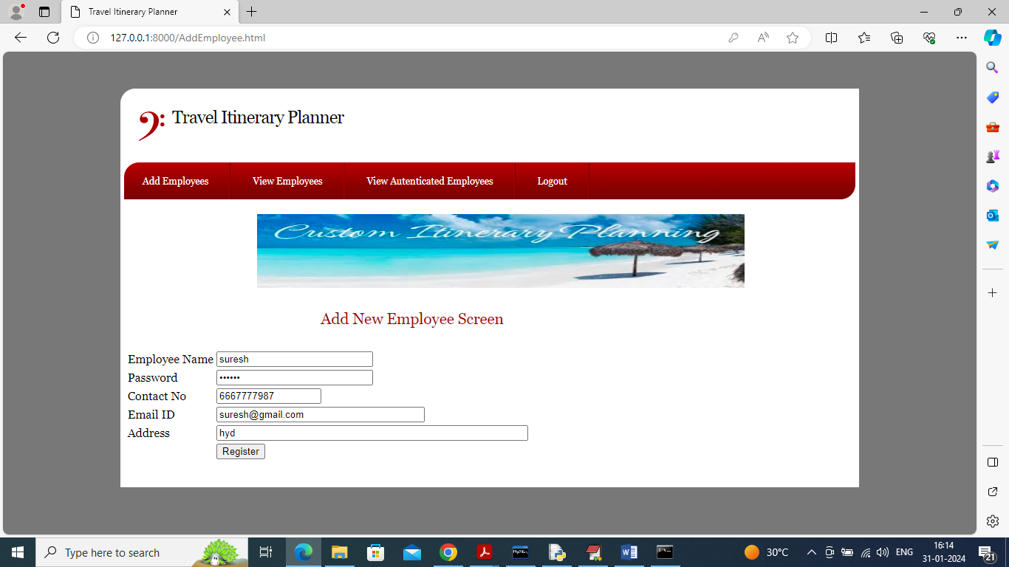

In above screen admin is entering employee details and then press button to get below page

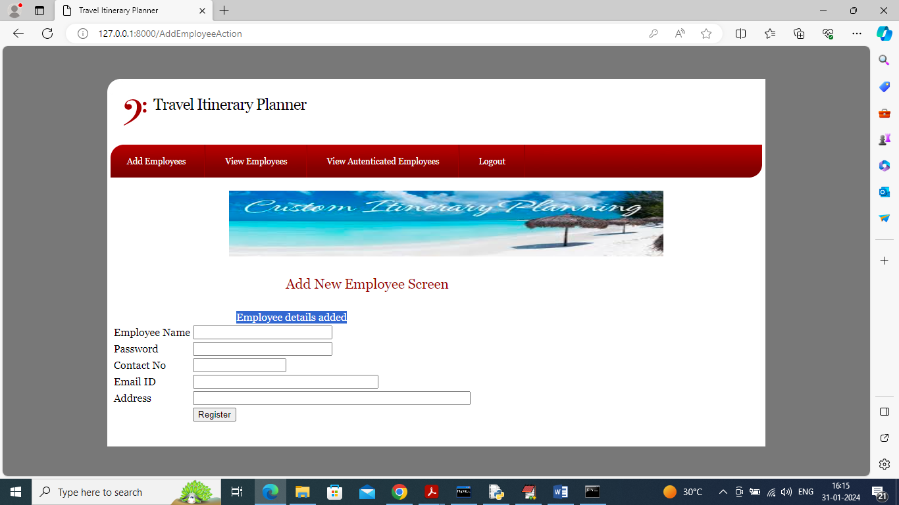

In above screen employee details added and now click on ‘View Employees’ link to get below list of employees

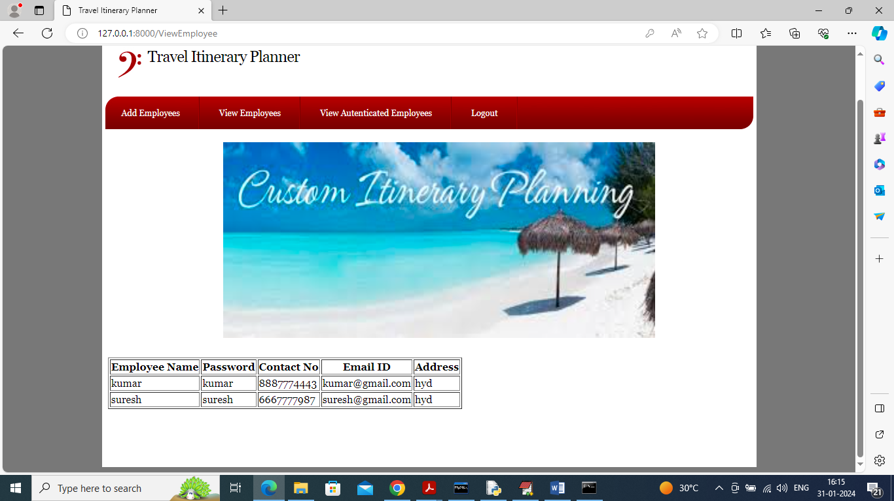

In above screen can see list of all employees and now click on ‘View Authenticated Employee’ link to view list of employee authenticated at different times

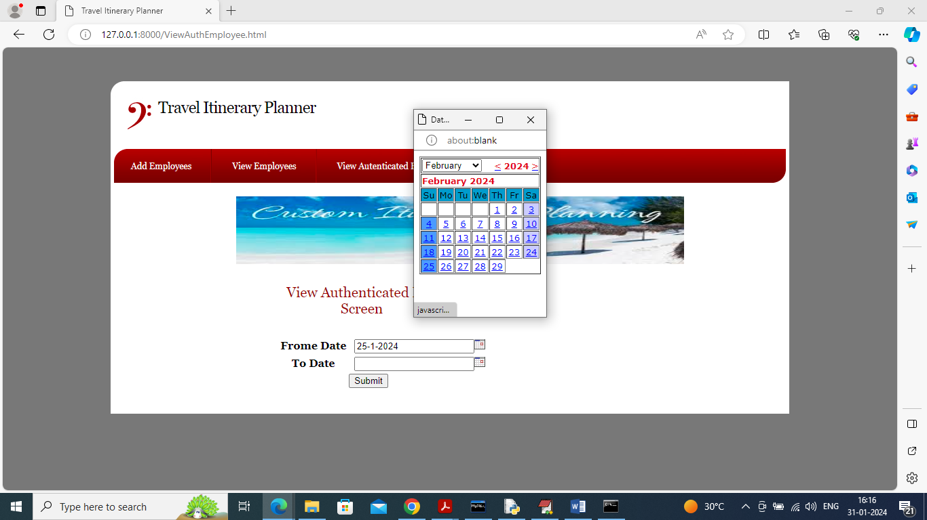

In above screen admin will select FROM and to date and then press button to get below list of authenticated employees

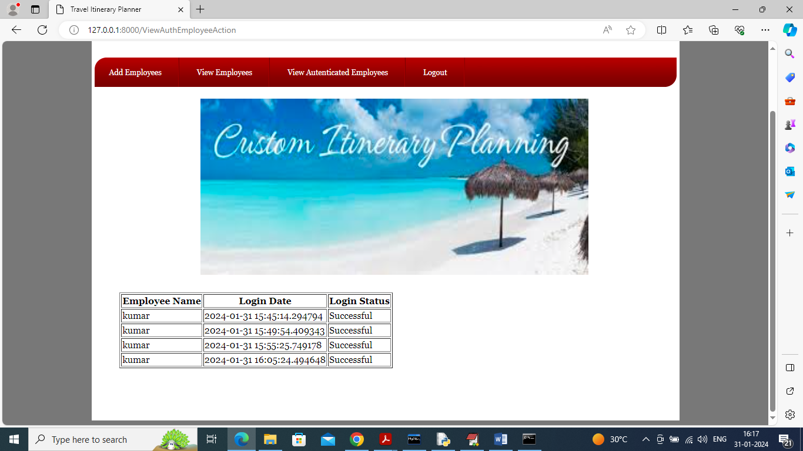

In above screen can see which employee authenticated on which date and time and now logout and login as employee

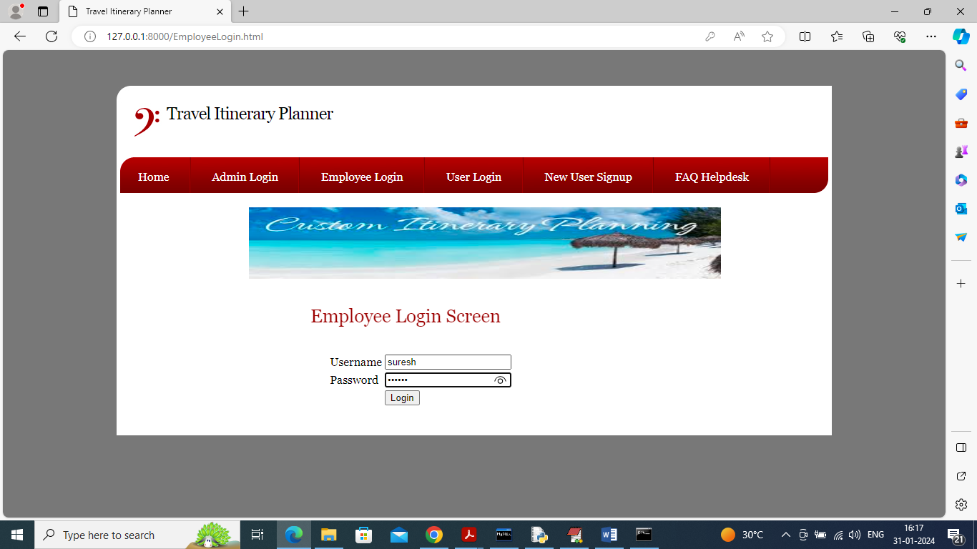

In above screen employee is login and after login will get below page

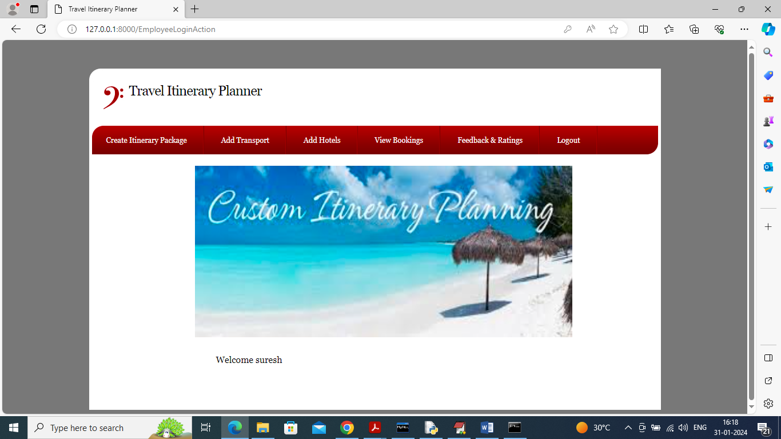

In above screen click on ‘Create Itinerary Package’ link to get below page

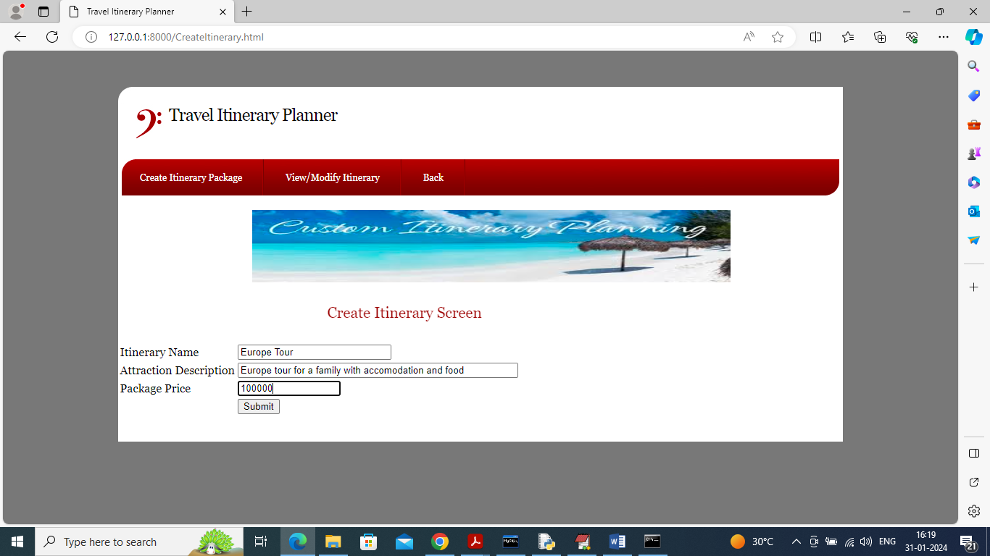

In above screen adding Itinerary package details and then press button to get below page

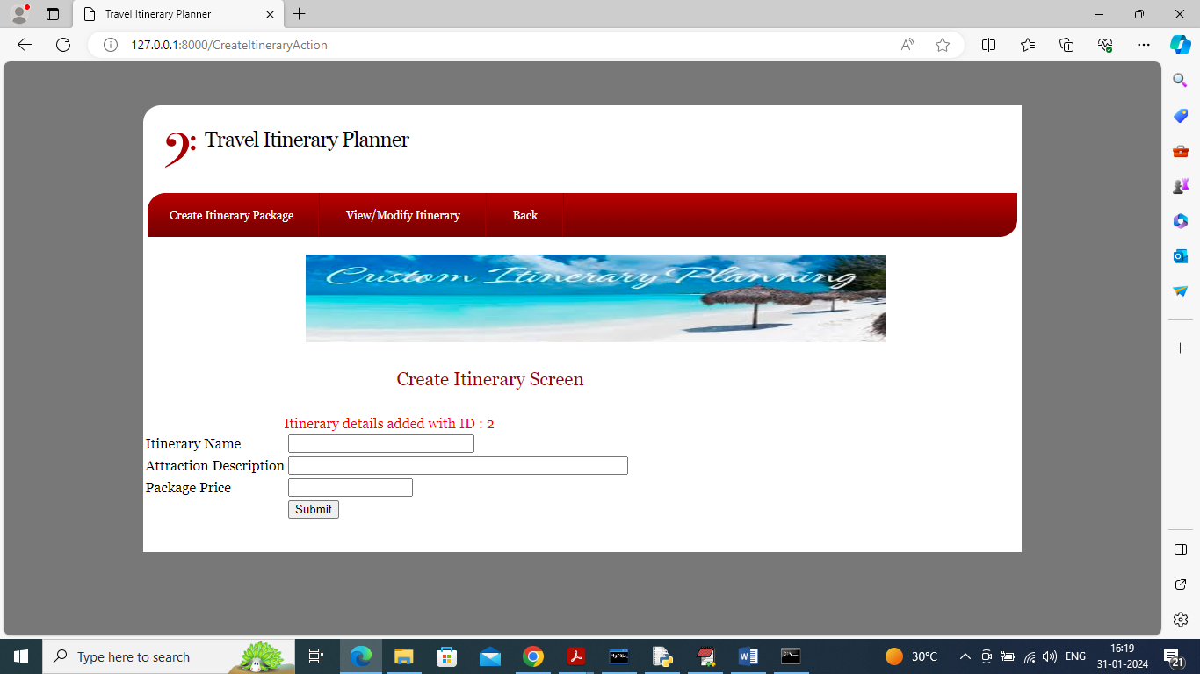

In above screen details added and now ‘View/Modify Itinerary’ link to get list of packages

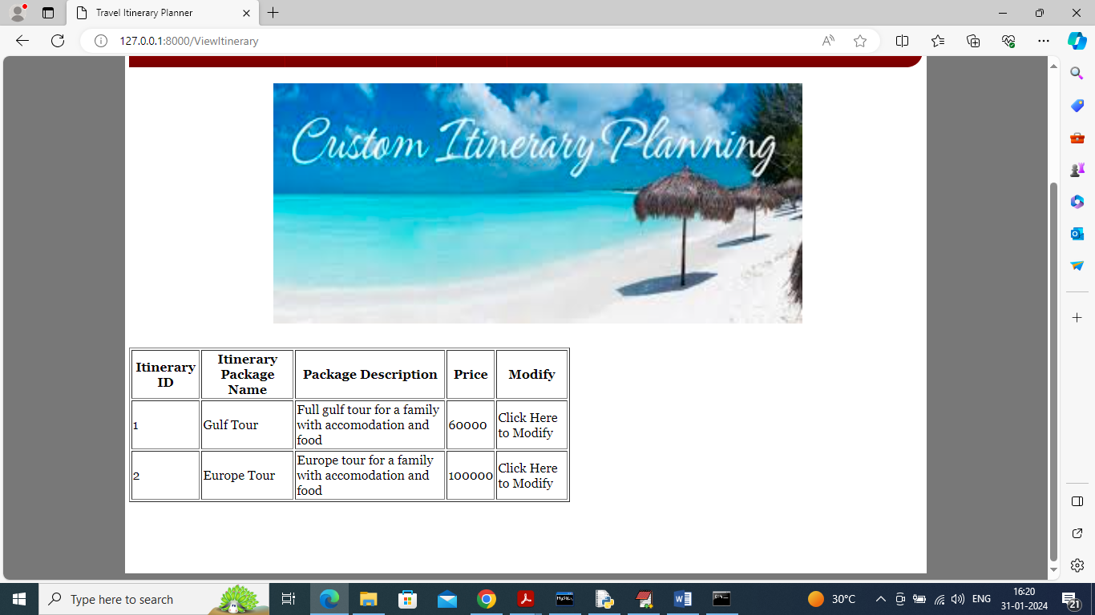

In above screen employee can view list of packages and can click on ‘Click Here’ link to modify package and get below page

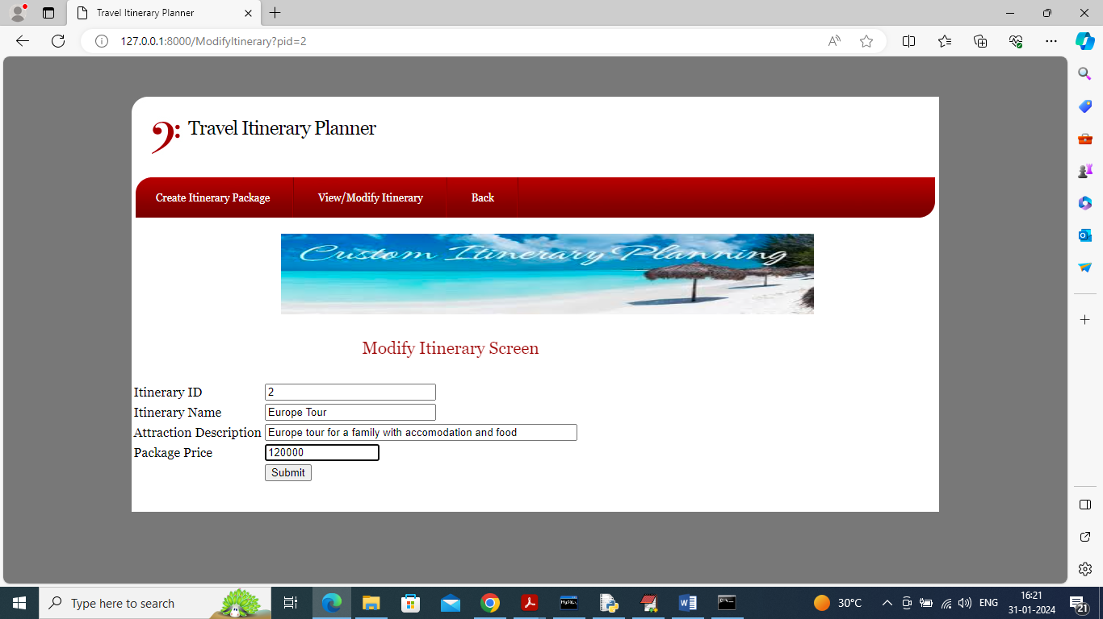

In above screen modify desired details and then press button to modify package and now click on ‘Back’ and then click on ‘Add Transport’ link

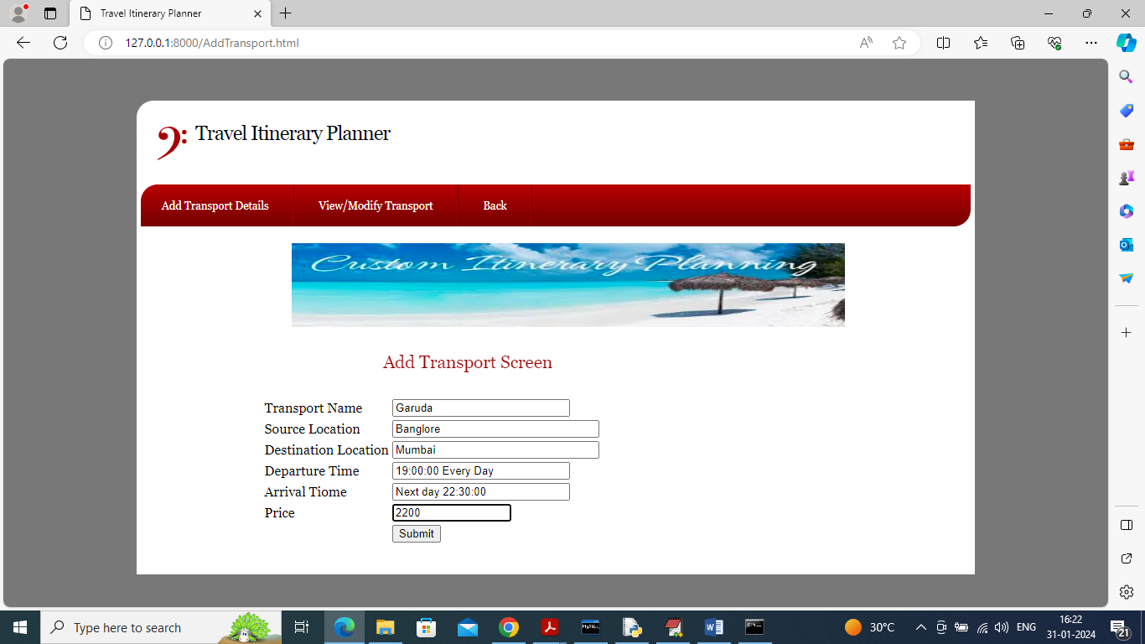

In above screen adding transport details and then press button to get below page

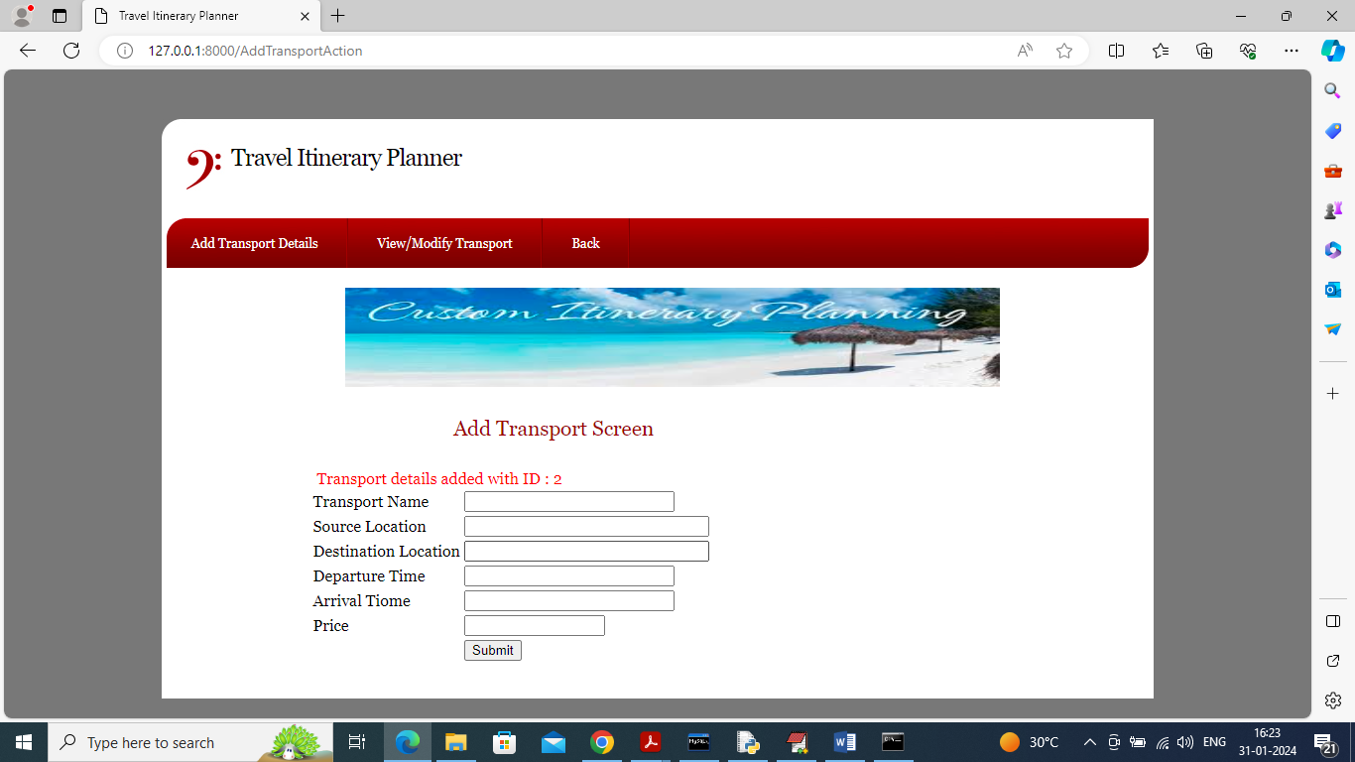

In above screen transport details added and now click on ‘View/Modify Transport’ link to get below page

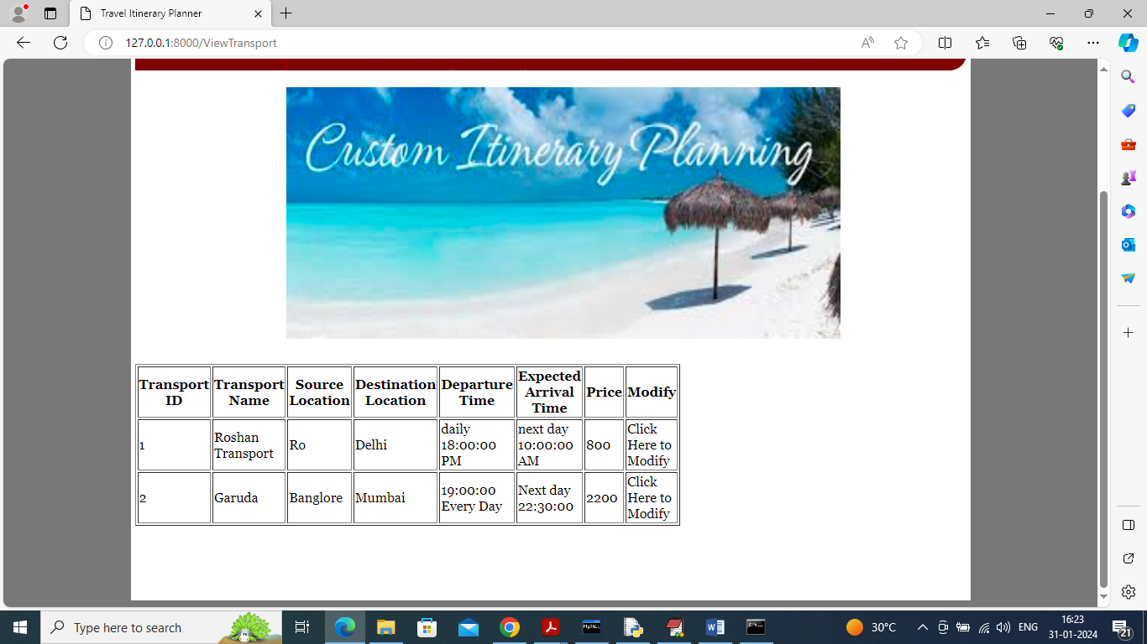

In above screen click on ‘Click Here’ link to modify required details and now click on ‘Back’ and ‘Add Hotel’ link to add hotel details

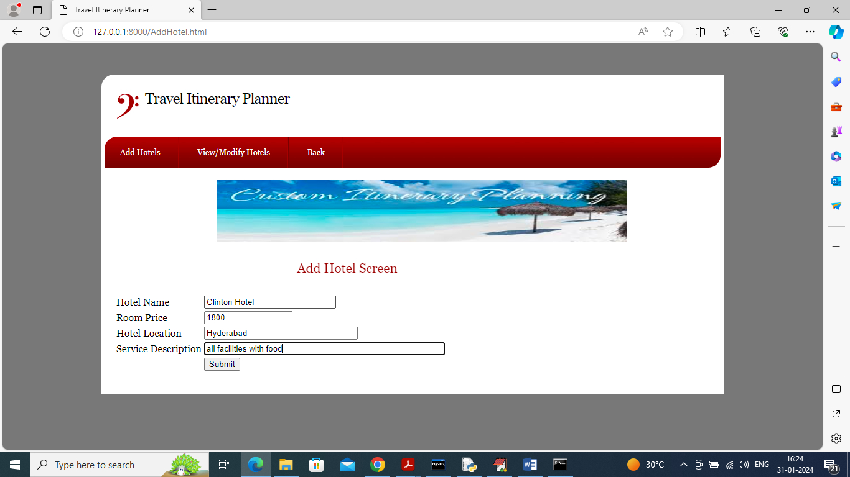

In above screen adding hotel details and click button to get below details

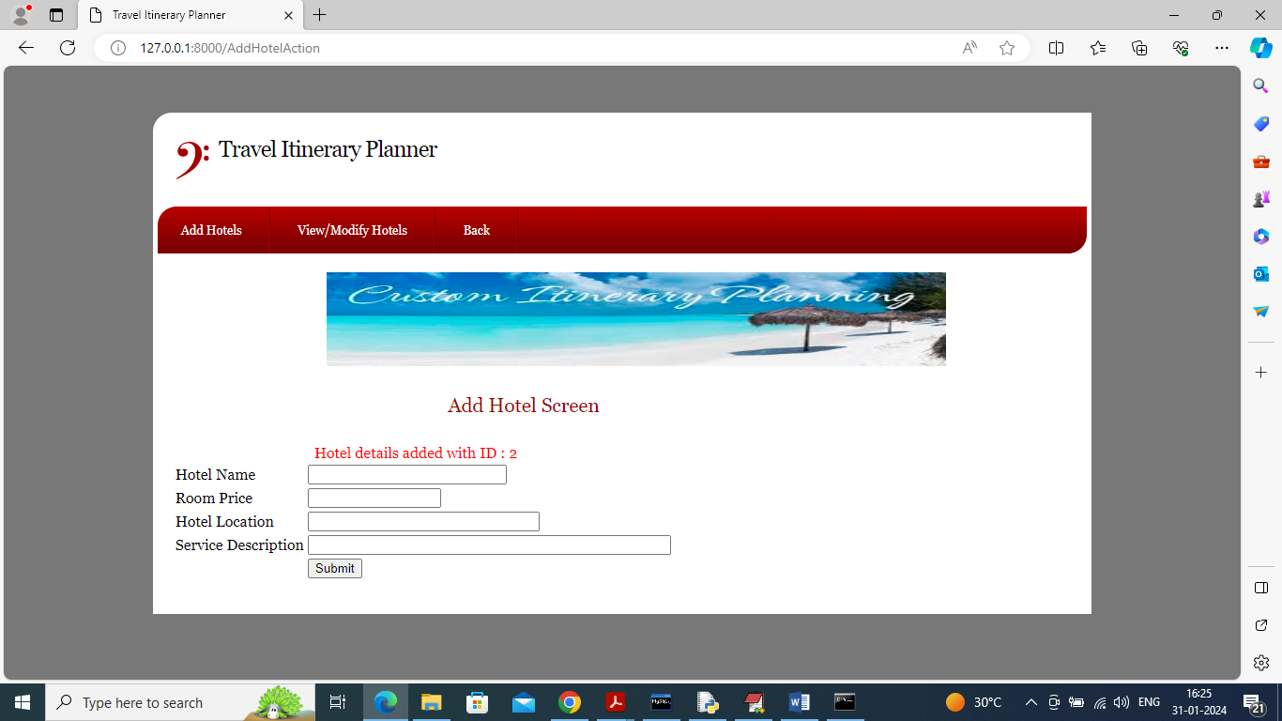

In above screen hotel details added and now click on ‘View/Modify Hotel’ link to get below page

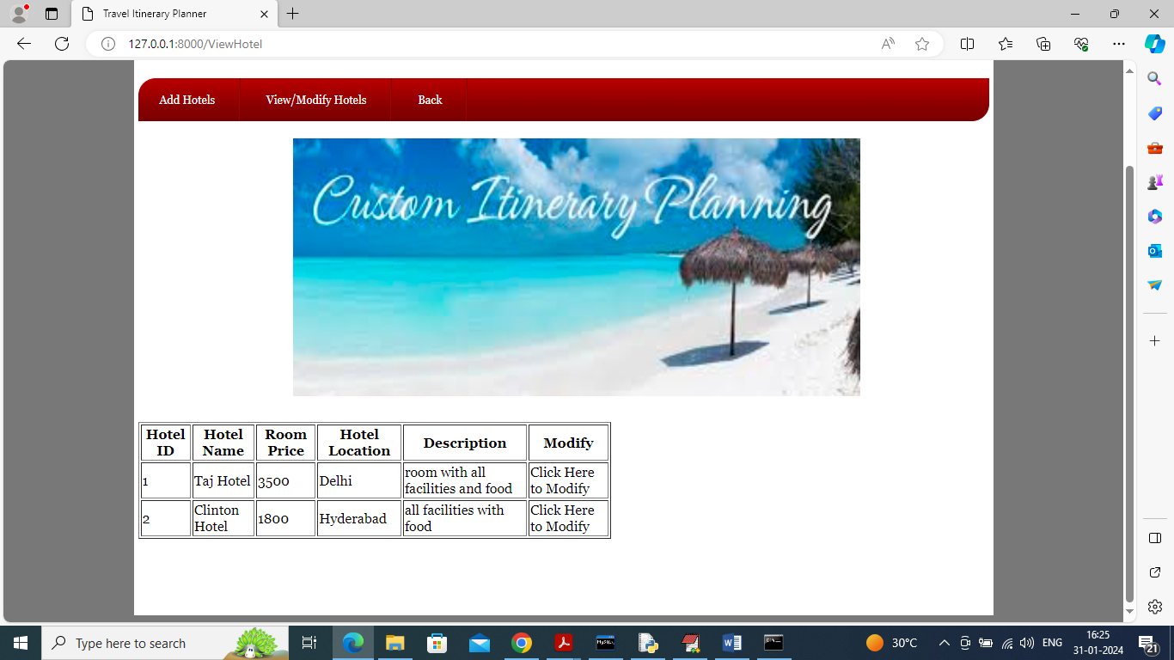

In above screen after viewing details can click on ‘Click Here’ to modify required details and now click ‘Back’ to get below page

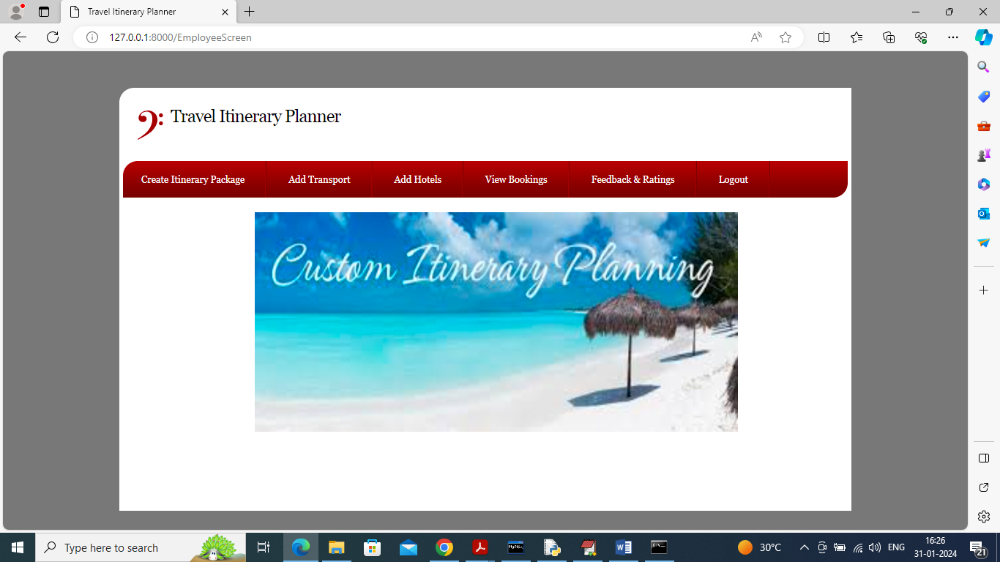

In above screen click on ‘View Booking’ link to view booking from all users

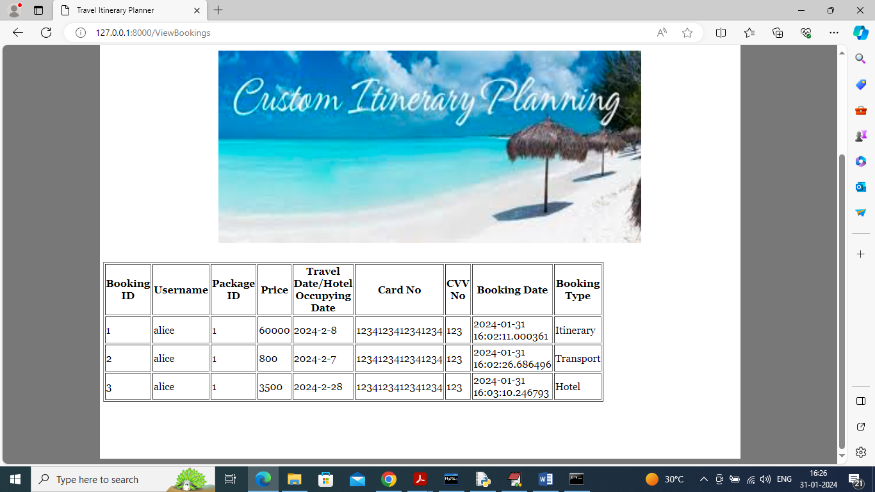

In above screen employee can view booking from all users and now click on ‘View Feedback’ link to view feedback from all users

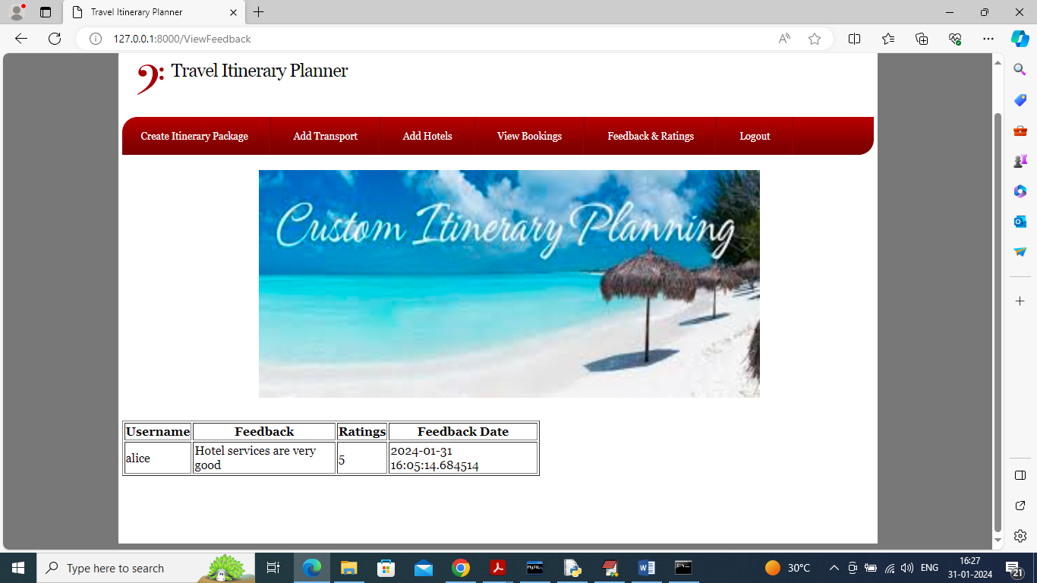

In above screen employee can view feedback from users and based on feedback employee will try to better service and now logout and sign up new user

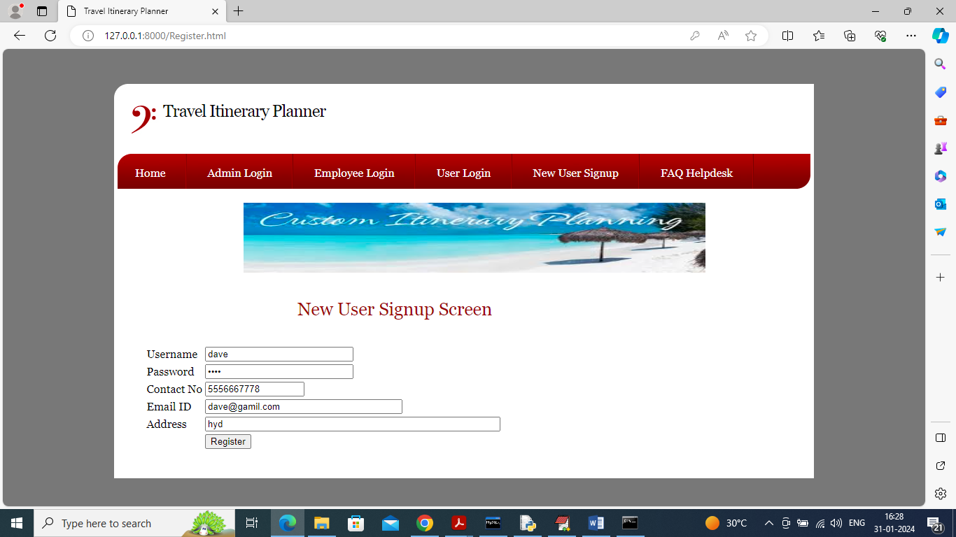

In above screen user is entering sign up details and then press button to get below page

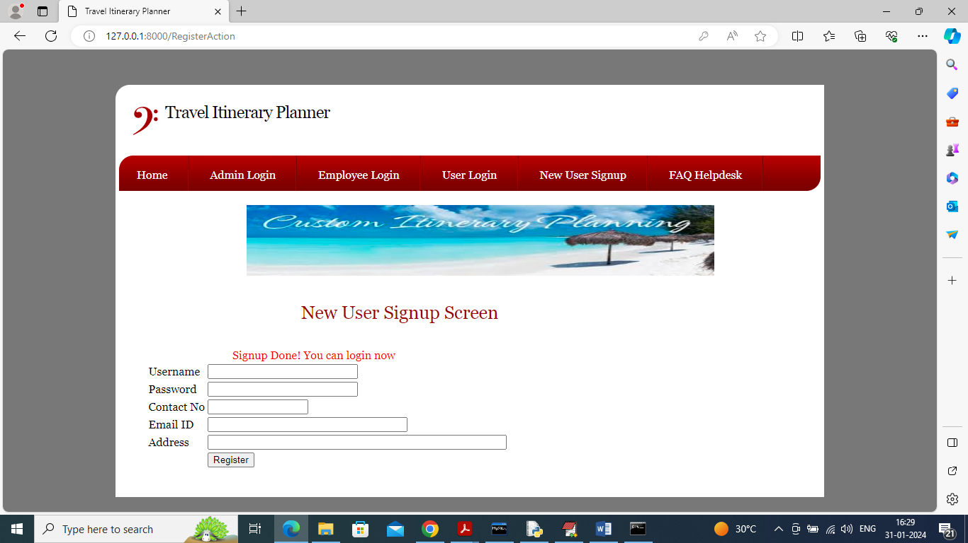

In above screen sign up completed and now click on ‘User Login’ to get below page

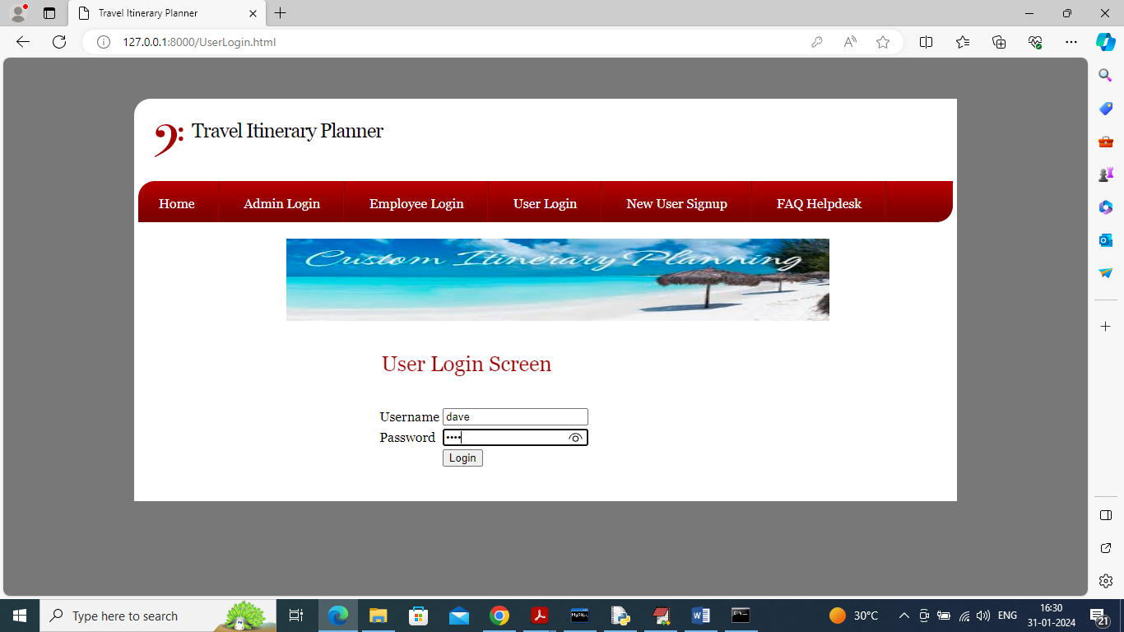

In above screen user is login and after login will get below page

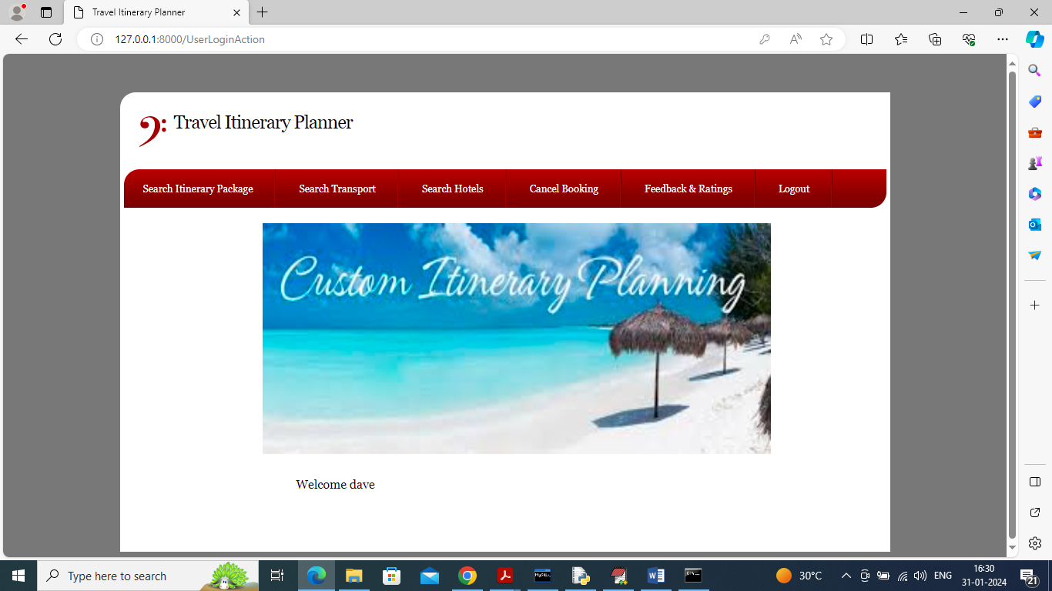

In above screen user can click on ‘Search Itinerary package’ link to get list itineraries

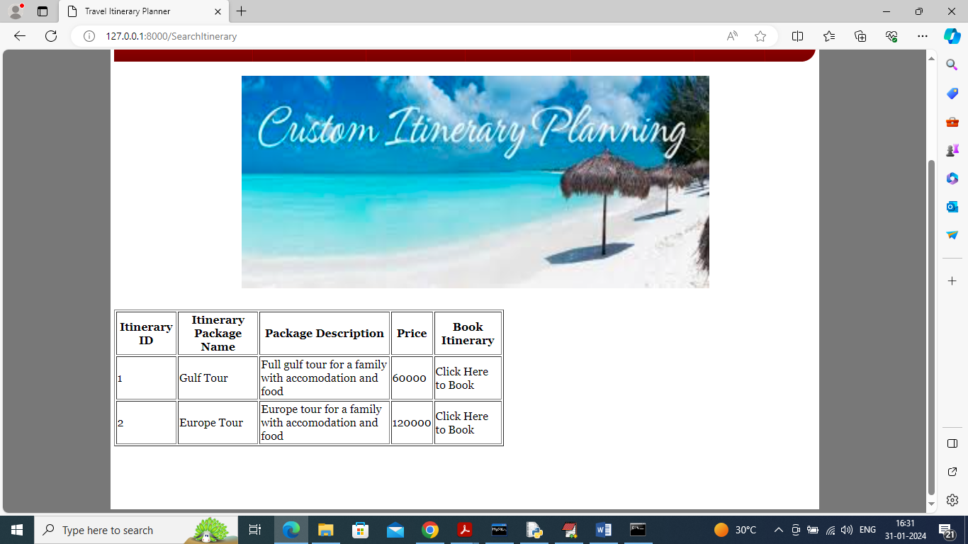

In above screen user can view list of itineraries and can click on desired Itinerary for booking and get below page

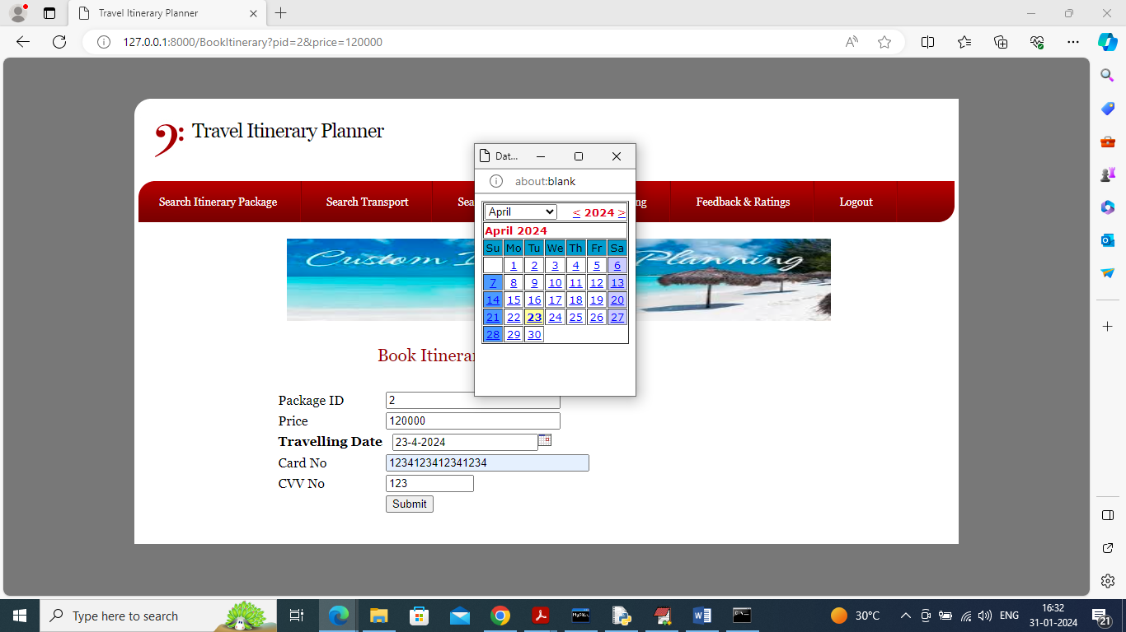

In above screen user will select travel date and then enter payment details to confirm package and then press button to get below page

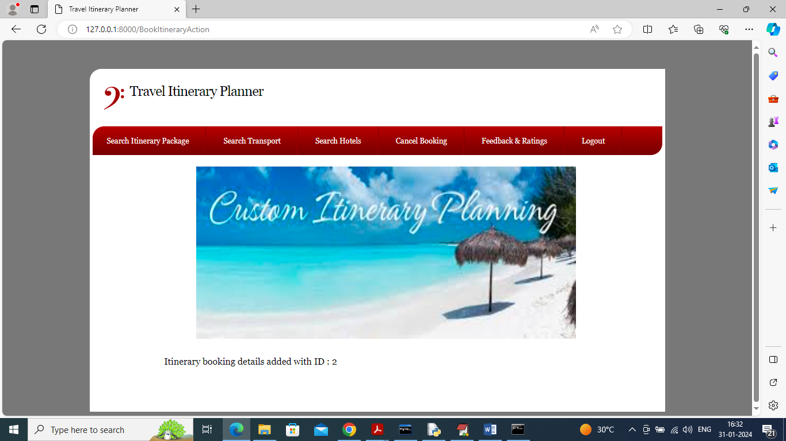

In above screen booking is confirmed and now click on ‘Search Transport’ to get list of transport

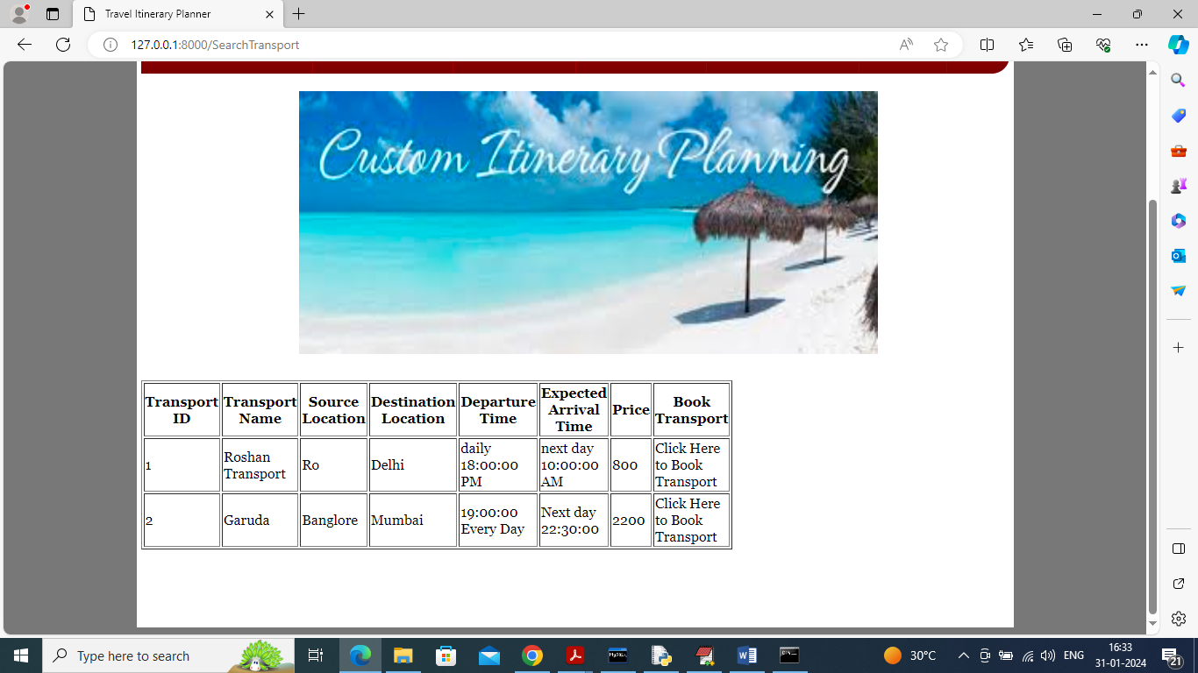

In above screen user can view list of transports and can click on desired transport for booking and now click on ‘Search Hotel’ link to get below page

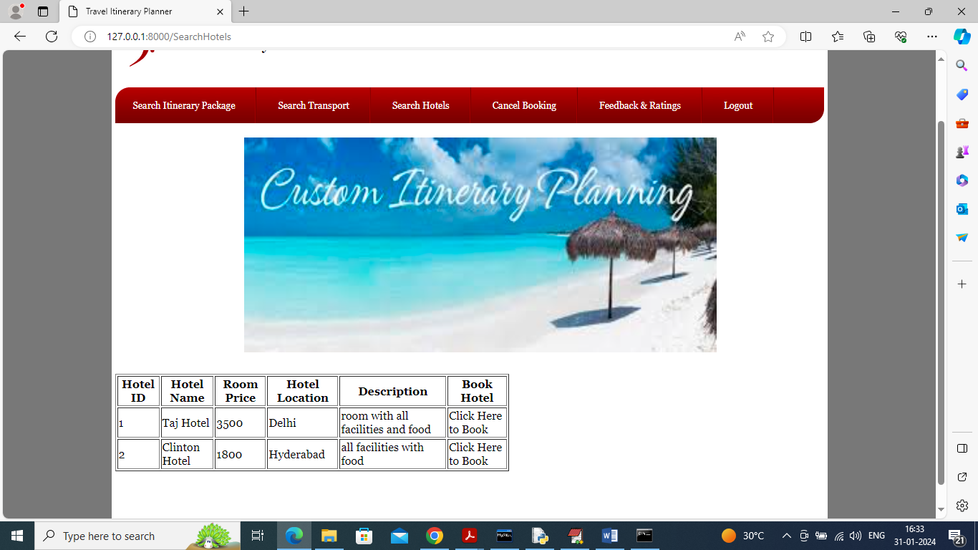

In above screen user can view list of hotels and can book desired hotel and now click on ‘Cancel Booking’ link to get all bookings

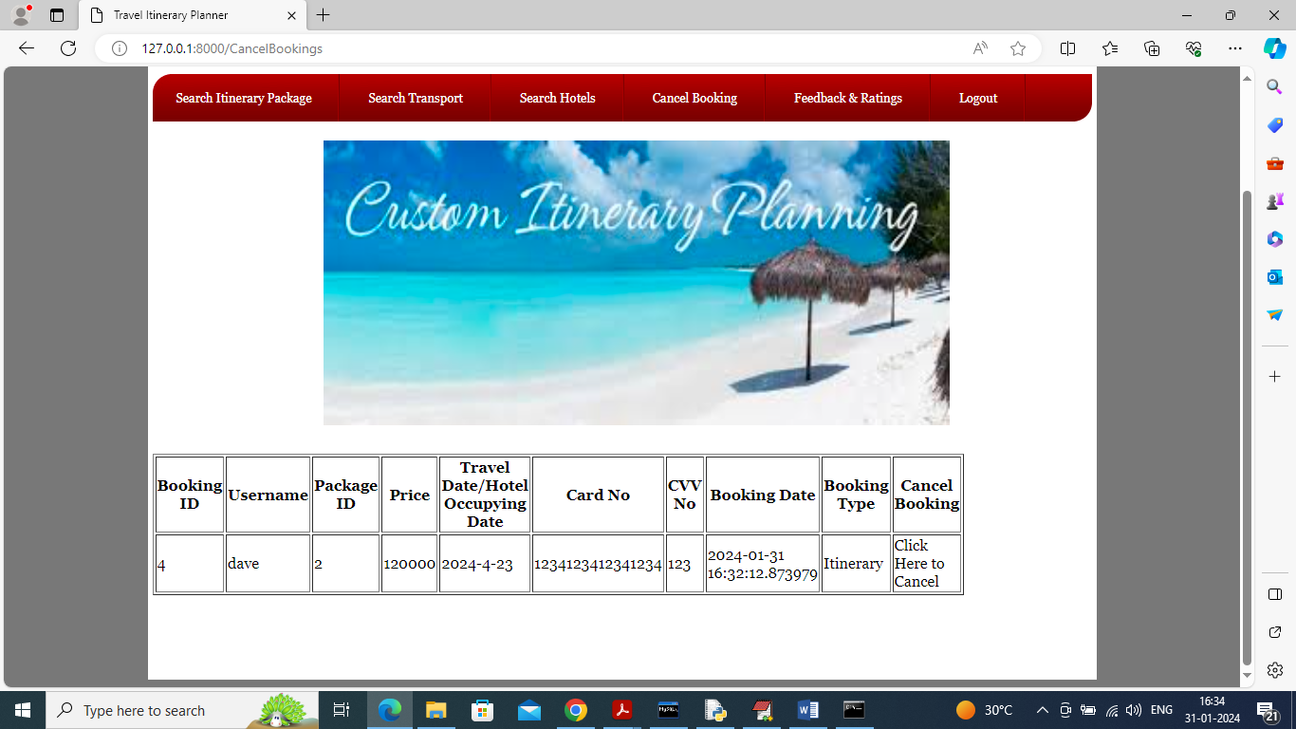

In above screen user can click on ‘Click Here To Cancel’ link to cancel booking and now click on ‘Feedback & ratings’ link to give feedback

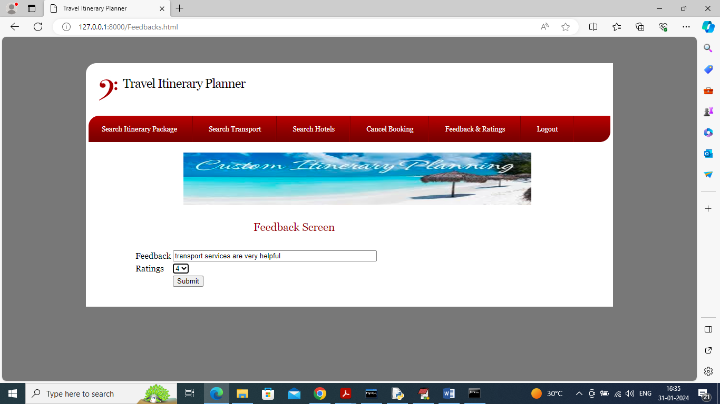

In above screen user will give feedback and press button to submit feedback to employee and then will get below page

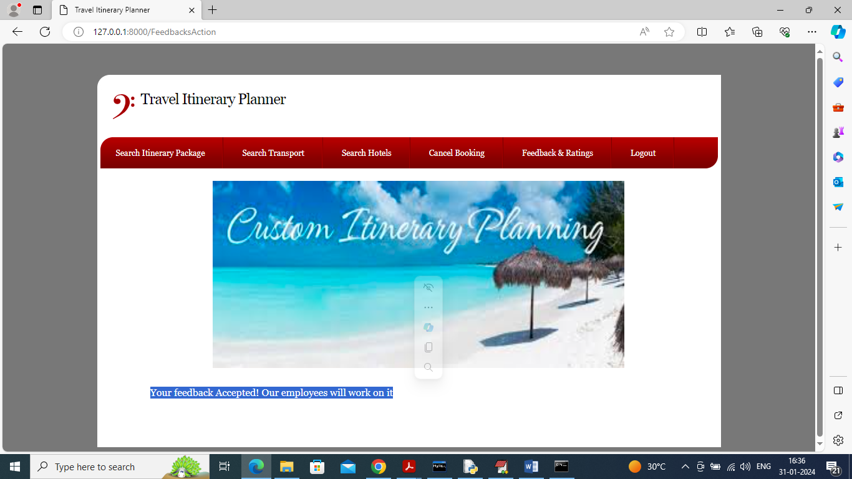

In above screen can see feedback response and similarly by using above screens you can make any number of bookings